Homework 3

Name: Ze Liu

RUID: 174007753

The formula (1.69):



The formula (1.70):

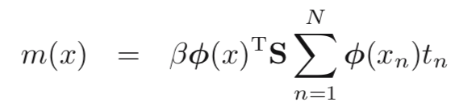

The formula (1.71):

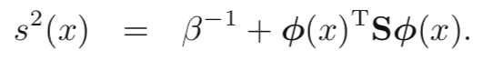

The formula (1.72):

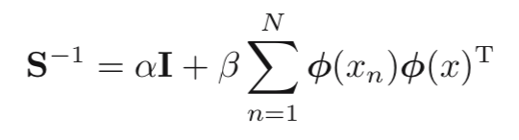

These four formulas are all implemented in my BCF.java.

For the stock, I download the stock history it shows at the YAHOO website and the total number for each stock is 251. The titles of columns are shown as following picture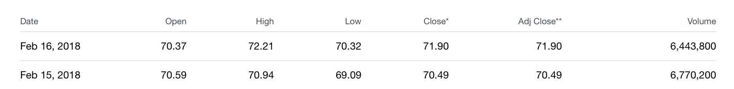

The result: 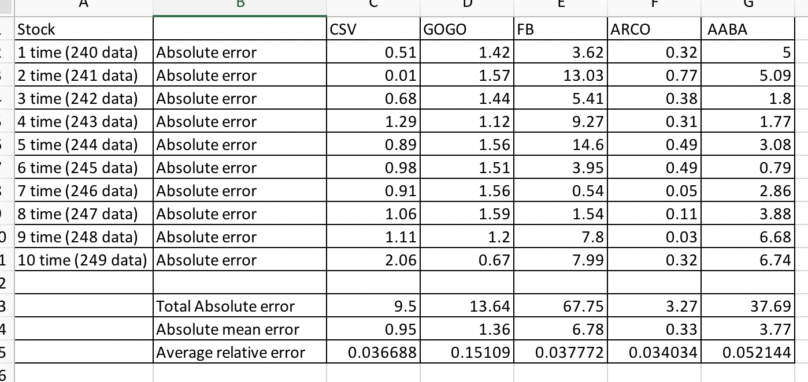

For each stock, I used Bayesian curve fitting and test it for ten times using different dataset, varying from 240 to 249. The best result for Absolute mean error is: 0.33 and Average relative error is: 0.034034